Annual Report of “Scheduled Caste Sub Plan SCSP)” Scheme (2021)

A central government sponsored and funded scheme, “Development Action Plan for Scheduled Caste (DAPSC) (formerly Scheduled Caste Sub Plan SCSP)” was implemented by the ICAR-CICR, Nagpur and its Regional Research Stations located at Sirsa (Haryana) and (Coimbatore). The main objective of this plan is to emphasize the developmental programmes for the Scheduled Castes, in relation to their agribusiness pattern and the need to increase productivity and income from their limited resources. The objective of the scheme was to increase the income levels of the targeted population through various income generating schemes, skill development and infrastructure development. The scheme was implemented in the selected PMAGY and other Non- PMAGY villages in four Districts of Maharashtra namely Nagpur, Wardha, Chandrapur and Bhandara where the Scheduled Caste population is 50% or more by identifying the beneficiary families with the help of State Government Agencies. The program planning was done at the institute level and executed by the committee members in the adopted villages. The poor families were targeted to directly use the various agricultural related inputs provided by the Institute. The scientific inputs in terms of technology dissemination, technological interventions, capacity building, showcasing technologies, exposure visits, interface meetings and trainings, skill up gradation, timely solutions of the farmer’s problems, cleanliness of public premises, sanitization and providing information of various schemes implemented by state agricultural departments.
Various activities were carried out in the adopted villages to provide direct benefit to the scheduled caste beneficiaries under the SCSP Scheme. These includes, organization of skill development programmes, trainings and workshops, distribution of Goat & Goat Feed, improved Cotton cultivation practices, ICAR-CICR Bt varieties, Paddy seed, Red Gram seed, Gram seed, Wheat seed, Fertilizers, vegetable seed kits, bio-fertilizer kit, Power weeder and printed cotton cultivation practices. The farmers were sensitized on round the year for Cotton production and its scientific cultivation, with complete package of practices and seeds.

Nodal Officer: Dr. S. M. Wasnik, Principal Scientist (Extension)
Members: Dr. J. H. Meshram, Principal Scientist (Plant Physiology),
Dr. Ramkrushna G. I., Sr. Scientist (Agronomy)
Dr. S. P. Gawande, Scientist (Plant Pathology),
Dr. B. B. Fand, Scientist (Entomology),
Dr. N. S. Hiremani, Scientist (Plant Pathology),
Dr. UV Galkate , SMS (Veterinary Sciences), KVK,
Shri. Akshay Kamble, Technician,
Shri. Akshay Barahate, Technician,
Shri. Eluka Shridhar, Technician,
SAO & FACO

The details of various programmes carried out under SCSP schemes for the period given below:

Sr. No. | Name of programme | Venue and Date | No of SC beneficiaries | Input distributed/  skill imparted
1. | Entrepreneurship development & various input distribution | Godhani village, Ta. Umred, Dist. Nagpur  4 February 2021. | 100 | - One day training cum farmers meets on ‘Agri-based business management’ & various critical input distributions.  - Power weeder handed over to the Grampanchyant Godhani.
2. | Poshan Vatika Maha Abhiyan’ and one day workshop on Integrated Pest and Disease Management in Cotton. | Dhurkheda, Ta. Umred, Dist. Nagpur  17 September 2021. | 200 | - Workshop on “Integrated pest and disease management in Cotton”.  - Poshan Vatika Maha Abhiyan
3. | Training program on Scientific Goat Farming cum  Female Goat & Goat Feed distribution. | Parsodi, Aptur, Jogithana, Kalmana, Khairi Buti, Makardhokada, Paradgaon, Thombara, Tirkhura, Salebhatti, Saleshahari, Dhurkheda, Champa, Godhani, Sonpur, Bondri, Kesalwada, Chakara, Bandar Shivapur, Amati, Kanheri Dongarmoh, Sawarkheda, Khobna, Bodakipeth, Amboli  January, March, April, November 2021 | 179 | - Training program on Scientific Goat Farming & livestock management  - Vaccinated Two female goats & 50 Kg Goat Feed distributed to each Scheduled caste Beneficiaries.
4. | Demonstrations of ICAR - CICR Bt varieties. | Pipmalgaon Lute, Durgada, Kavtha, Welsakhara, Bandar  June & July 2021 | 58 | - Seeds of ICAR-CICR Suraj Bt and ICAR-CICR Rajat Bt variety were distributed to farmer for the demonstration purpose.
5. | Tur Seed Distribution | Kawatha,Nandpur;  Shekapur, Chitki  Pimplagaon Lute,  Durgada, Welsakhra, Thombra, Godhani,  Dhurkheda, Amboli,  Dhanla, Kuhi,  Bandar, Kesalwada  June & July 2021 | 625 | - Tur seed and bio-Fertilizer kit distributed for intercropping to Scheduled caste farmers for Kharif season.  - PKV – TARA variety of tur having packing 2 kg (4 Kg to each) distributed to the farmers.
6. | Paddy Seed Distribution | Dhanala, Bandar, Kesalwada, KVK-PDKV Sakoli  June & July 2021 | 183 | - Paddy seed distributed CO-51 & PDKV–Tilak variety of paddy distributed to Scheduled caste farmers for Kharif season.
7. | Bio-fertilizer Kit Distribution | Amboli, Amti, Bandar, Chitki, Dhanla, Dhurkheda, Durgada, Girad, Godhani, Kawatha, Kesalwada, Khapri, Khobna, Bodkhi Peth, Kuhi, Nandpur, Pauni, Pipardol, Pimplagaon Lute, Sawarkheda, Sillori, Shekapur, Sonapar, Sonpur, Tekari, Thombra, Tirkhura, Wadegaon, Welsakhra  June, October & November 2021 | 1020 | • Bio-fertilizer Kit Contain 4 items namely Rhizobium,  PSB-Phosphate Solubilising Bacteria, Azotobacter and Trichoderma were distributed.
8. | Fertilizers –  NPK (10:26:26), Urea, DAP, MOP Distribution | Kavtha, Nandpur, Chitki, Pauni, Shekapur, Amti, Pimpalgaon Lute, Durgada, Welsakhara, Thombara, Godhani, Dhurkheda, Amboli, Kuhi, Bandar, Tekari,  Khobna, Bodakipeth, Khapari, Pipardol, Sillori, Sawarkheda,  Tirkhura, Sonapar, Wadegaon  July, October & November 2021 | NPK - 680  Urea - 228  DAP - 395  MOP - 140 | - Distributed to Scheduled caste farmers for Kharif and Rabi crop & to create awareness among the farmers to use fertilizers for higher yield & good quality crop produce.
9. | Gram Seed (Chickpea) Distribution | Durgada, Welsakhara, Thombara, Amboli, Tekari, Khobna, Bodakipeth, Khapari, Amti, Sawarkheda, Sillori, Pipardol, Tirkhura, Pauni, Sonapar, Wadegaon.  October & November 2021 | 450 | - Gram seed and bio-Fertilizer kit Distributed to Scheduled caste farmers for Rabi season.  - Gram Variety, Jaki-9218 having packing 30 Kg & Rajvijay- 202 having packing 20 Kg distributed to 300 & 150 farmers respectively.
10. | Wheat Seed Distribution | Durgada, Tekari  October & November 2021 | 75 | - Wheat seed and bio-Fertilizer kit Distributed to Scheduled caste farmers for Rabi season.  - Wheat variety Phule Samadhan having packing 40 kg one bag to each distributed to the farmers.
11. | Skill up gradation programme on improved methods of vegetable cultivation & vegetable seed kit distribution. | Kawatha, Durgada,  Pimplagaon Lute,  Welsakhra, Thombra,  Godhani, Dhurkheda,  Amboli, Pipardol, Pauni,  Tirkhura, Wadegaon, Khobna, Bodkhi Peth, Sawarkheda, Amti, Kuhi, Sonapar, Sillori, Sonpur, Khapri, Tekari, Bandar, Girad  June, October & November 2021 | 726 | - Sensitisation on scientific  Management of vegetable crops and off-season vegetable production.  - Seeds of various vegetables like cucumber, hybrid bottle gourd, hybrid brinjal, cowpea, cluster bean, chilli, ridge gourd and other critical inputs.

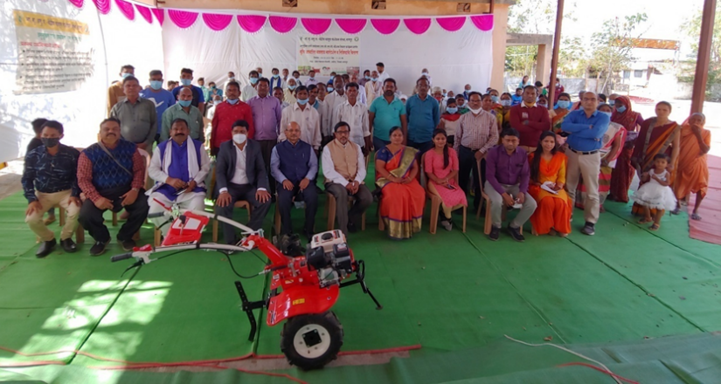
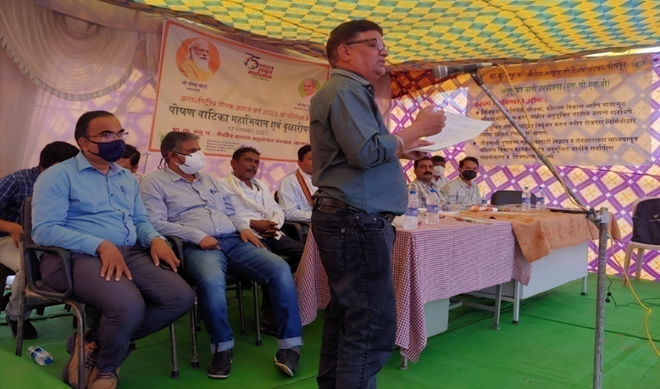
Entrepreneurship development workshop & various input distribution at Godahni village Th. Umred, Dist. Nagpur
Dr. S. M. Wasnik, addressing to the farmers at. Dhurkheda, Ta. Umred, Dist. Nagpur

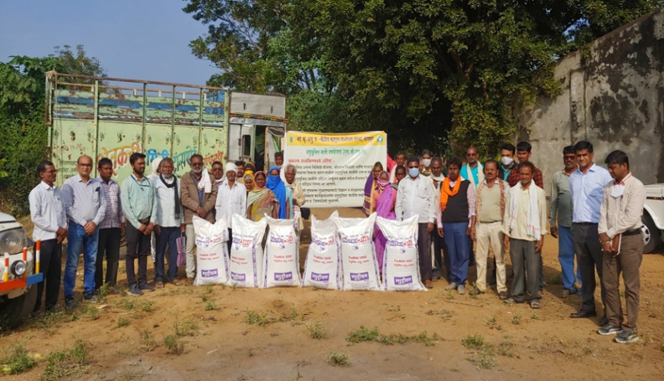
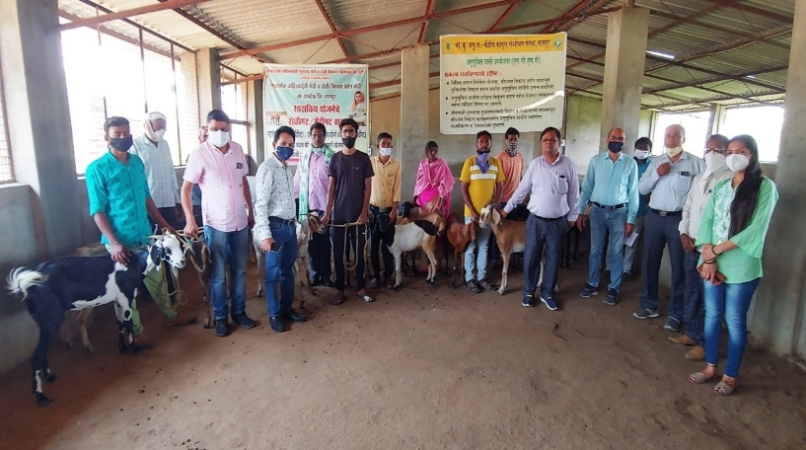
Female Goat distribution to SC beneficiaries under SCSP scheme

Goat Feed distribution along with Goat beneficiary

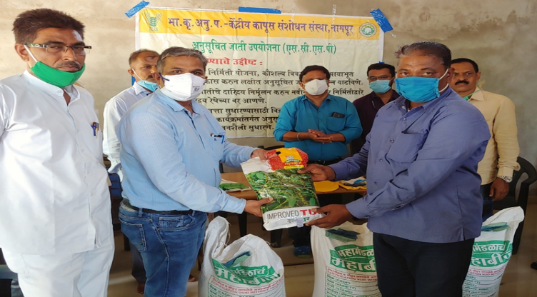
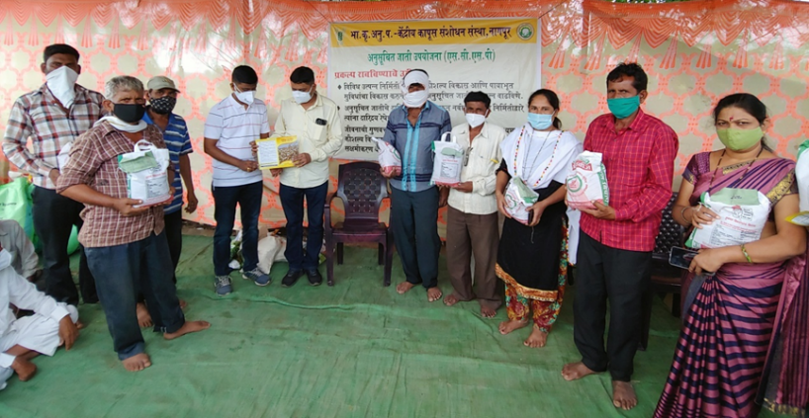
Red Gram (Tur) seed distribution at Dhanla village Ta. Kuhi, Dist. Nagpur under SCSP Scheme.
Cotton Seed distribution to farmers under SCSP scheme

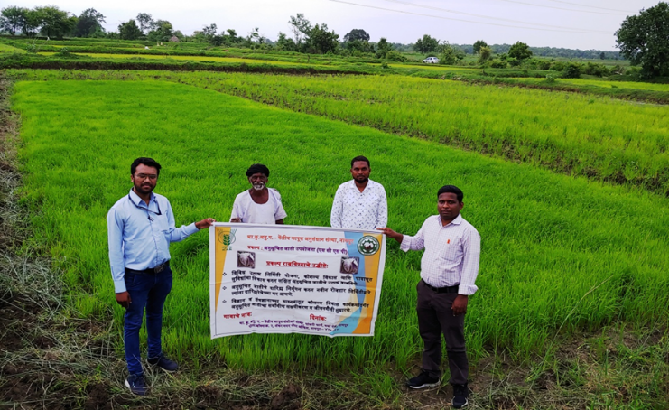
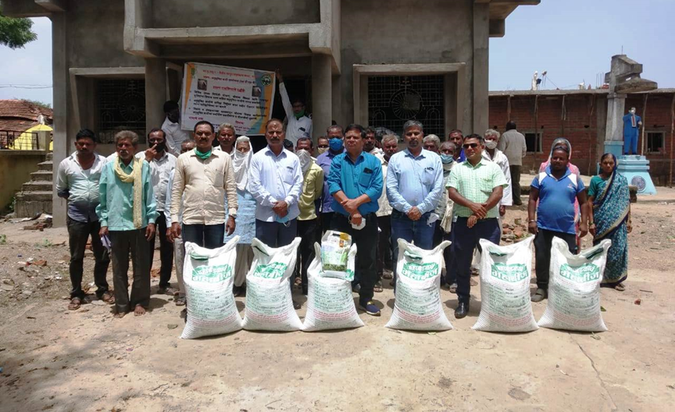
Field visit of Paddy crop at Bandar Ta. Chimur, Dist. Chandrapur under SCSP Scheme
Paddy seed distribution at Dhanla village Ta. Kuhi, Dist. Nagpur under SCSP Scheme.

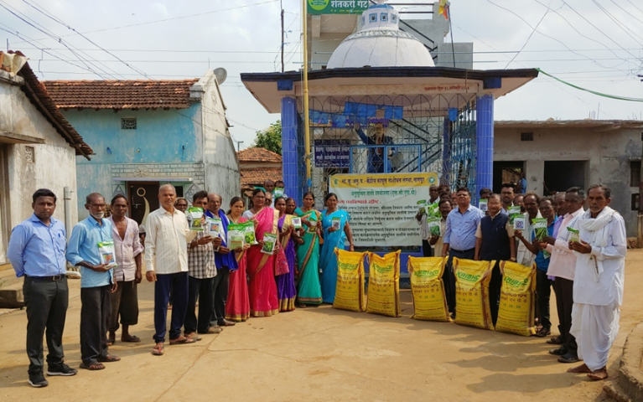
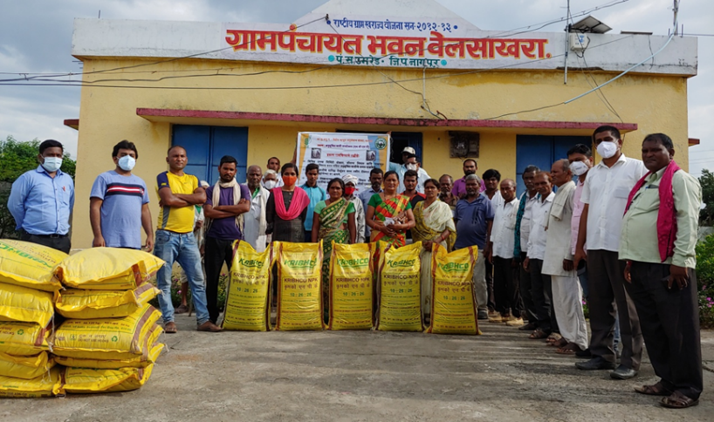
Vegetable seed kit distribution at Tekari village, Th. Nagbhir, Dist. Chandarpur under SCSP.
Fertilizer Distribution at Welsakhra village Th. Umred, Dist. Nagpur under SCSP.

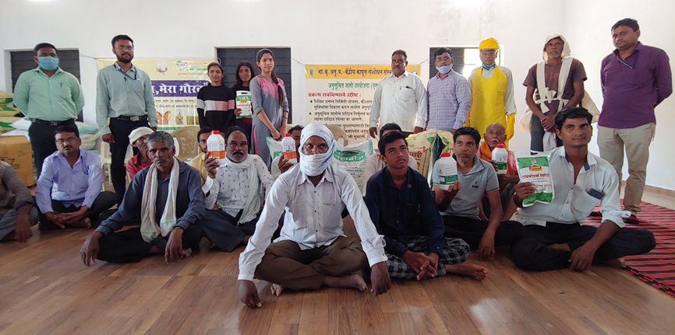

Bio fertilizer kit distribution to farmers at Sonapar village, Th. Kalmeshwar, Dist. Nagpur under SCSP

