Annual Report of “Development Action Plan for Scheduled Caste (DAPSC) (formerly SCSP) 2023”
A central government sponsored and funded scheme, “Development Action Plan for Scheduled Caste (DAPSC) (formerly Scheduled Caste Sub Plan SCSP)” was implemented by the ICAR-CICR, Nagpur. The main objective of this plan is to emphasize the developmental programmes for the Scheduled Castes, in relation to their agribusiness pattern and the need to increase productivity and income from their limited resources.
The objective of the scheme was to increase the income levels of the targeted population through various income generating schemes, skill development and infrastructure development. The scheme was implemented in the selected PMAGY and other Non- PMAGY villages in Six Districts of Maharashtra namely Nagpur, Wardha, Chandrapur, Amaravati, Yavatmal and Bhandara where the Scheduled Caste population is 50% or more by identifying the beneficiary families with the help of State Government Agencies. The program planning was done at the institute level and executed by the committee members in the adopted villages. The poor families were targeted to directly use the various agricultural related inputs provided by the Institute. The scientific inputs in terms of technology dissemination, technological interventions, capacity building, showcasing technologies, exposure visits, interface meetings and trainings, skill up gradation, timely solutions of the farmer’s problems, cleanliness of public premises, sanitization and providing information of various schemes implemented by state agricultural departments.
Various activities were carried out in the adopted villages to provide direct benefit to the scheduled caste beneficiaries under the DAPSC. These includes, organization of skill development programmes, trainings and workshops, distribution of Goat & Goat Feed, improved Cotton cultivation practices, Paddy seed, Red Gram seed, Soybean seed, Gram seed (Chickpea), Wheat seed, Crop protection Kit (Insecticide & Fungicide Kit), Tarpaulin, Sickle, Pesticide Protection Kit, Irrigation pipe (Lapeta pipe), Battery Operated Knapsack Sprayer, Cattle feed & Mineral Salt Block, Cotton picking bags and printed cotton cultivation practices. Also recognizing the crucial role of women farmers in agriculture, concerted efforts were made to mobilize women from SC families and facilitate the formation of self-help groups (SHGs) through awareness programs. These SHGs received technical assistance through capacity building, Entrepreneurship development and empowering them to generate year-round income vegetable cultivation and nutri-gardens. The farmers were sensitized on round the year for Cotton production and its scientific cultivation, with complete package of practices and seeds.
The programme was implemented with involvement of the following team members of SCSP committee constituted by the authority

Nodal Officer: Dr. J. H. Meshram, Principal Scientist (Plant Physiology)
Members: Dr. Ramkrushna G. I., Sr. Scientist (Agronomy)
Dr. S. P. Gawande, Sr. Scientist (Plant Pathology),
Dr. B. B. Fand, Sr.Scientist (Entomology),
Dr. N. S. Hiremani, Scientist (Plant Pathology),
Dr. U.V Galkate, SMS (Veterinary Sciences), KVK,
Shri. Akshay Kamble, Technician,
Shri. Akshay Barahate, Technician,
CAO & FACO

The details of various Training programmes carried out under the DAPSC during 2023.

Sr.  No. | Name of programme | Venue and Date | No of SC beneficiaries | Programmes Details
1. | Farmer Science Congress on the occasion of Indian Science Congress | Rashtrasant Tukdoji Maharaj Nagpur University Campus, Nagpur  05 January 2023. | 100 | - Farmers meet and training.
2. | Farmers Meet on Agri-Innovations for Sustainable Productivity" | Dr. Ambedkar College, Dekshabhoomi, Nagpur  04 March 2023. | 60 | - Interface Farmers Meeting on Agri-Innovations for Sustainable Productivity"
3. | Health Camp | ICAR-CICR, Nagpur  24 March 2023 | 140 | - One Day workshop on Cardiac arrest cum Health Check up Camp
4. | Cotton farmers wrokshop, Pre-Kharip Consultation | ICAR- Central Institute for Cotton Research, Nagpur.  19 May 2023. | 183 | - Conducted Workshop on “Pre-Kharip Consultation: Technologies & Best Management Practices for Enhancing Cotton Productivity”.
5. | Cotton farmers wrokshop, Pre-Kharip Consultation: Technologies & Best Management Practices for Enhancing Cotton Productivity | ICAR- Central Institute for Cotton Research, Nagpur.  30 May 2023. | 166 | - One day Farmers training program on ‘Integrated Cotton Crop management ’.
6. | "One day Workshop for Women Farmers" "Training for capacity building and entrepreneurship development of farm women" | Durgada Ta. Deoli, Dist. Wardha  23 June 2023 | 60 | - One day Workshop for Women Farmers on Ambar Charkha (Cotton Spinning machine) Unit.
7. | PM-Kisan Samman Nidhi Programme, Input distribution-cum training on cotton crop | ICAR- Central Institute for Cotton Research, Nagpur.  27 July 2023. | 80 | - Farmers training on Cotton cultivation cum exposure visit at CICR Cotton fields.
8. | Training on “Cotton technology outreach and interventions for cotton productivity, Enhancement and Livelihood improvement of farmers of selected villages in parambalur district, Tamilnadu” | ICAR-KVK Valigandapuram, Perambalur, Tamilnadu  06 November 2023 | 50 | - Farmers meet cum training on Pest and Disease management
9. | Kisan Mela | ICAR- Central Institute for Cotton Research, Nagpur.  19 December 2023. | 139 | - Farmers meet cum training on Pest and Disease management.
The details of Critical input distribution carried out under the SCSP schemes during 2023.

Sr. No. | Name of Item | Venue and Date | No of SC beneficiaries | Input distributed/  skill imparted
1. | Cattle feed & Mineral Salt Block | Dhurkheda, Ta. Umred & Mendhepathar (Jungali), Ta. Katol, Dist. Nagpur  15 February 2023 &  09 March 2023 | 120 | - One day Training on “Milch animal feeding management” and Distribution of Cattle feed & Mineral Salt Block to SC beneficiaries from Pipardol, Amboli, Welsakhara, Godhani, Wadegaon, Tirkhura and Dhurkheda, Ta. Umred & Chikhali Maina, Mendhepathar, and Wadvihara, Ta. Katol Dist. Nagpur.
2. | Vegetable Seed Kit | Welsakhara. Godhani Thombra, Pipardol, Mendhepathar, Hingna, Amti, Durgada, Khadki, Rampuri, Wadvihara, Parsodi, Khobna, Bodkhipeth, Pavani, Wadegaon, Palwadi, Sultanpur  April to June 2023 | 494 | Vegetable seed kit having 8 Type of seeds namely  - Coriander  - Spinach (Palak)  - Pumpkin  - Ridge Gourd  - Bottle Gourd  - Bitter Gourd  - Cowpea  - Chillies  Distributed to SC beneficiaries
3. | Osmanabadi Goat | ICAR- Central Institute for Cotton Research, Nagpur.  12 April 2023. | 4 | - 7 Female and 1 Male Osmanabadi Goat distributed to SC beneficiary from Chikhali Maina, Ta. Katol, Dist. Nagpur
4. | Goat and Goat feed | Punyashlok Ahilyadevi Mendhi Va Sheli Vikas Prakshetra, Bondri, Taluka. Ramtek, Dist. Nagpur  01 May 2023 | 85 | - Vaccinated Two female goats & 50 Kg Goat Feed distributed to each Scheduled caste Beneficiary from Chikhali Maina, Mendhepathar, Ta. Katol, Dhurkheda, Ta. Umred. Dist. Nagpur. Parsodi, Ta. Pauni, Dist. Bhandara and Tekri, Ta. Nagbhir, Dist. Chandrapur.
5. | Battery Operated Knapsack Sprayer | Pipardol, Pavani, Wadegaon, Khobna, Bodkhipeth, Amti, Mendhepathar, Wadvuhara, Hingna, Rampuri, Khadki, Durgada, Parsodi, Gandhinagar, Malkapur, Sherad, Mangaon, Salapur | 490 | - Distributed Battery Operated Knapsack Sprayer to SC beneficiaries used for spraying liquids such as pesticides, insecticides, herbicides, fungicides, etc., in fields to protect the crop from pest attack and provide crop nutrients.
6. | Crop Protection Kit | Pipardol, Wadegaon, Pavani, Amti, Khobna, Bodakhipeth, Chikhali Maina, Mendhepathar, Waadvihara, Khadki, Parsodi, Rampuri, Hingna, Durgada, Husenpur, Sultanpur, Katsur  (Khaif season) | 500 | - Crop Protection kit contain Fungicides & Insecticides namely  - Neem Oil  - Flonicamid (50WG)  - Profenofos (50%EC)  - Propiconazole (25EC)  - Propineb (70WP)  - Metiram 55% + Pyraclostrobin 5% WG
7. | Nutrient kit | Pipardol, Mendhepathar, Hingna, Amti, Durgada, Khadki, Rampuri, Wadvihara, Parsodi, Khobna, Bodkhipeth, Pavani, Wadegaon, Chikhali Maina, Husenpur, Sultanpur, Katsur  (Kharif season) | 500 | - Nutrient kit contain fertilizer and micro nutrient namely  - Zinc Sulphate Monohydrate (33% Zinc)  - Boron Fertilizer (20%)  - Mono Potassium Phosphate (0:52:34)  - NPK Fertilizer (19:19:19)  - Nano Urea
8. | Soybean Seed | Wadegaon, Khadki, Wadvihara, Mendhepathar, Parsodi, Durgada, Palwadi, Husenpur, Sultanpur, Katsur, Chikhali Maina  (Kharif season) | 200 | - Soybean Seed variety Phule Sangam distributed to farmers.
9. | Tur Seed | Wadegaon, Pipardol, Khadki, Wadvihara, Khobna, Parsodi, Hingna, Rampuri, Durgada, Pavani, Palwadi, Chikhali Maina, Sawarkhanda, Tirkhura  (Kharif season) | 300 | - Tur (PKV – TARA)  Seed distributed for Cotton intercropping to Scheduled caste farmers for Kharif season.  - PKV – TARA variety of tur having 2 kg packing (4 Kg to each) distributed to the farmers.
10. | Paddy Seed | Wadegaon, Pipardol, Khobna, Bodkhipeth, Amti, Sawarkhanda.  (Kharif season) | 106 | - PDKV–Tilak variety of Paddy seed distributed to Scheduled caste farmers for Kharif season.
11. | Cotton Seed | Gram Panchayat Khobna, Ta. Kuhi, Dist. Nagpur  28 June 2023 | 49 | - One Day Farmers Field Training on “Improved Cotton Production Technology”.  - Moksha & Jai ho variety of Cotton distributed to Scheduled caste farmers from Khobna, Bodkhipeth, Amti, Sawarkhanda Ta. Kuhi, Dist. Nagpur for Kharif season.
12. | Pendimethalin | Gram Panchayat Khobna, Ta. Kuhi, Dist. Nagpur  28 June 2023 | 30 | - Pendimethalin herbicide distributed to Scheduled caste farmers from Khobna, Bodkhipeth, Amti, Ta. Kuhi, Dist. Nagpur for Kharif season.
13. | Bio-Fertilizers Kit | Wadegaon, Pipardol, Khadki, Wadvihara, Mendhepathar, Khobna, Parsodi, Hingna, Rampuri, Durgada, Pavanai, Palwadi, Husenpur, Sultanpur, Katsur, Chikhali Maina, Sawarkhanada, Tirkhura.  (Kharif Season) | 500 | Bio-Fertilizer kit having powder based and liquid based fertilizers namely  - Rhizobium  - Tricoderma
14. | Pesticide Protection Kit | Husenpur, Sultanpur, Katsur, Mangaon, Salapur, Gandhinagar, Malkapur, Sherad  September to November 2023 | 171 | - Pesticide protection kits including Safety jackets, goggle, hand gloves, face mask, gum boots, safety helmet etc. were distributed among SC farmers.  - Useful for safe handling of pesticides in agriculture field.
15. | Tarpaulin | Husenpur, Sultanpur, Katsur, Mangaon, Salapur, Gandhinagar, Malkapur, Sherad  September to November 2023 | 171 | - Standard size Tarpaulins distributed among SC farmers to protect the crop/seed from rain.
16. | Sickle | Sultanpur, Ta. Teosa, Dist. Amravati  12 September 2023 | 16 | - Distributed 2 Sickle to each SC beneficiary.
17. | Vermicompost Bed | Husenpur, Ta. Teosa, Dist. Amravati  12 September 2023 | 28 | - Standard size 12”4”2” beds of Vermicompost pits were distributed to SC farmers.  - Vermicompost bed provided to turn waste into organic compost to promote organic farming.
18. | Cotton Picking Bag | Mangaon, Salapur, Gandhinagar, Malkapur, Sherad  November 2023 | 115 | - KVK-CICR innovated Cotton Picking bag distributed among SC beneficiary.  - Useful in clean and easy way of cotton picking.
19. | Gram Seed(Chickpea) | Palwadi, Husenpur, Sultanpur, Katsur, Parsodi, Rampuri, Pavani, Mangaon, Salapur, Durgada, Gandhinagar, Malkapur, Sherad, Wadegaon, Amboli, Tirkhura, Pipardol, Amti, Bodkhipeth, Khobna, Sawarkhanda, Wadvihara, Khadki, Khairi Punjab, Hingna, Mendhepathar.  October & November 2023 | 500 | - Gram seed Distributed to Scheduled caste farmers for Rabi season.  - Gram Variety, Jaki-9218 having packing 30 Kg bag. (one bag to each farmer)
20. | Wheat Seed | Palwadi, Husenpur, Sultanpur, Katsur, Parsodi, Rampuri, Pavani, Durgada, gandhinagar, Malkapur, Sherad, Wadegaon, Amti, Bodakhipeth, Sawarkhanda, Khadki, Khairi Punjab, Mendhepathar.  October & November 2023 | 250 | - Wheat seed Distributed to Scheduled caste farmers for Rabi season.  - Wheat variety ‘MACS-6222’ having packing 20 kg bag. (two bag to each farmer)
21. | Bio-Fertilizer Kit | Palwadi, Husenpur, Sultanpur, Katsur, Parsodi, Rampuri, Pavani, Mangaon, Salapur, Durgada, Gandhinagar, Malkapur, Sherad, Wadegaon, Amboli, Tirkhura, Pipardol, Amti, Bodkhipeth, Khobna, Sawarkhanda, Wadvihara, Khadki, Khairi Punjab, Hingna, Mendhepathar.  October & November 2023 | 750 | Bio-Fertilizer kit having powder based and liquid based fertilizers namely  - Rhizobium  - PSB  - Azatobacter  - Tricoderma
22. | Irrigation Pipe  (Lapeta Pipe) | ICAR- Central Institute for Cotton Research, Nagpur.  19 December 2023. | 140 | 60 Meter Irrigation Tube (Lapeta Pipe) distributed to SC farmers from Malkapur, Sherad, Gandinagar, Ta. Kalamb, Dist. Nagpur and Mangaon, Salapur, Ta. Samudrapur, Dist. Wardha on the occasion of Kisan Mela.
23. | Crop Protection Kit | ICAR-KVK Valigandapuram, Perambatur, Tamilnadu | 50 | Distributed input namely Ulala 60 gm, Emamectin Benzoate 100g, Cabrio top 300g, Planifix 100ml, All19-4kg, PN-4kg, Westa boran-2kg, MAP – 2kg, NSKE 1L, Pseudomonas 1kg, Imidactoprid 17.8% SL 250ml, Lambdacyhalothrin 5% EC 500ml, Profenofos 50% EC 500ml, Carbendazim 50% WP 1kg.

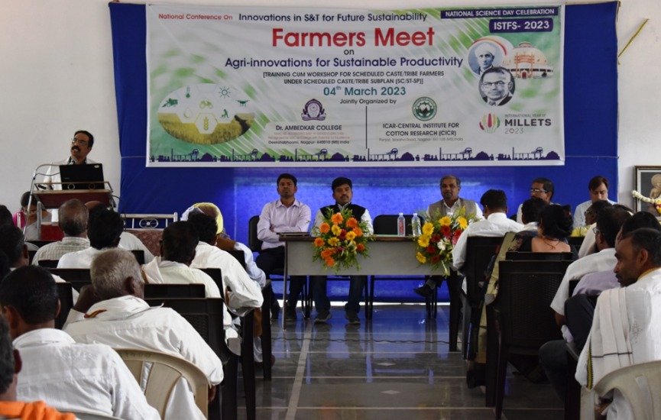
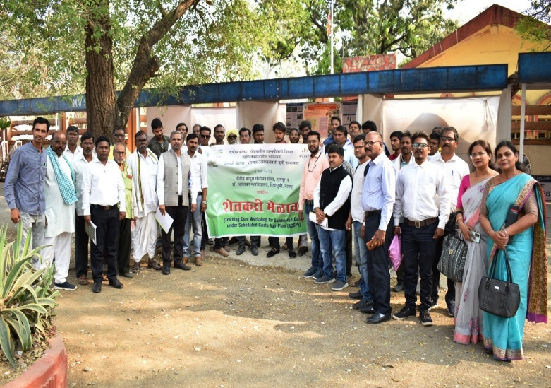
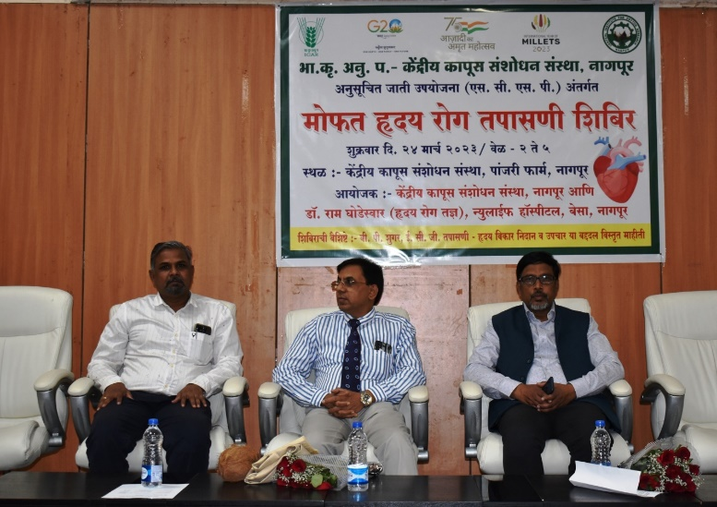
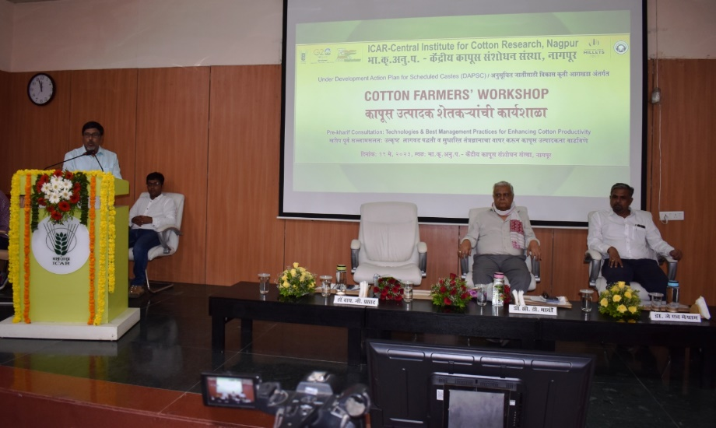
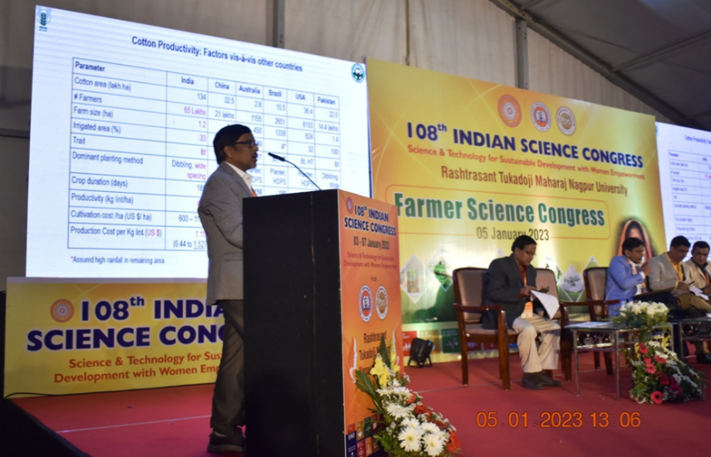
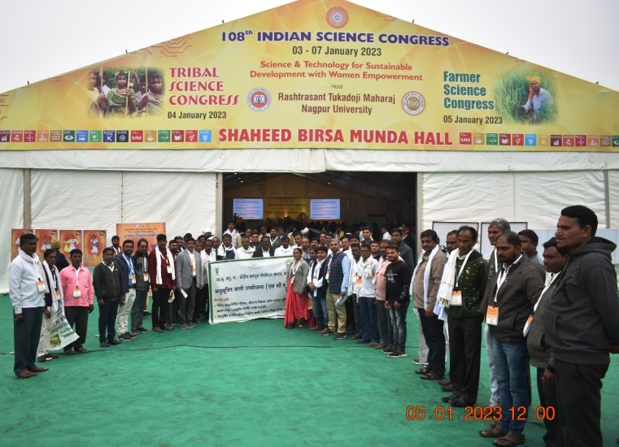
Farmers Meet on Agri-Innovations for Sustainable Productivity at Dr. Ambedkar College, Dekshabhoomi, Nagpur

Farmers Meet on Agri-Innovations for Sustainable Productivity at Dr. Ambedkar College, Dekshabhoomi, Nagpur

One Day workshop on Cardiac arrest cum Health Check up Camp at ICAR-CICR, Nagpur

COTTON FARMERS WROKSHOP on Pre-Kharip Consultation: Technologies & Best Management Practices for Enhancing Cotton Productivity at ICAR-CICR, Nagpur

SC Farmers participated in ‘Farmer Science Congress’ on the occasion of 108th Indian Science Congress at RTMNU Campus, Nagpur

Dr. Y. G. Prasad, Director CICR, Addressing in ‘Farmer Science Congress’ on the occasion of 108th Indian Science Congress at RTMNU Campus, Nagpur

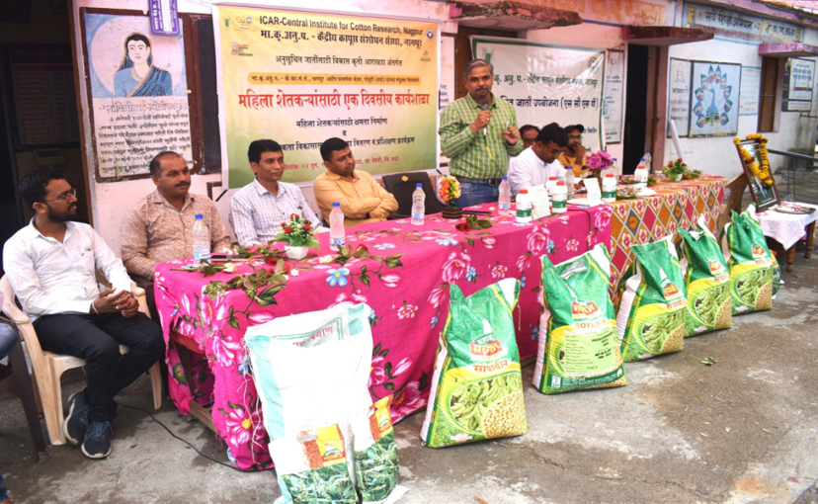
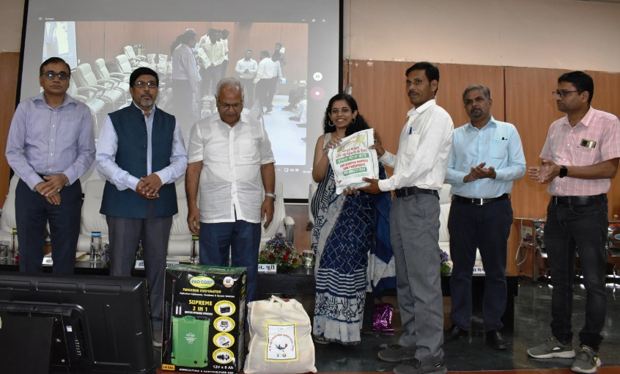
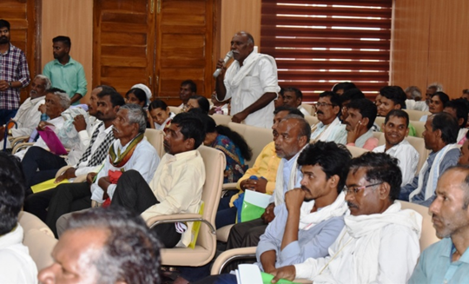
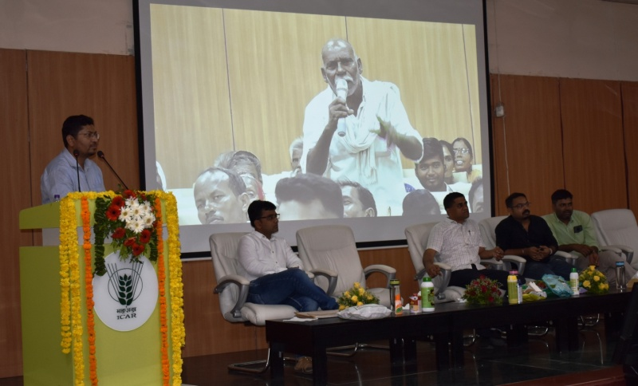
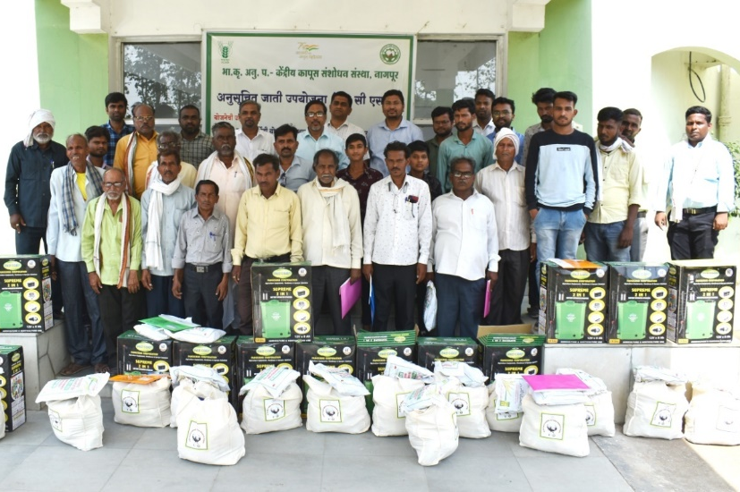
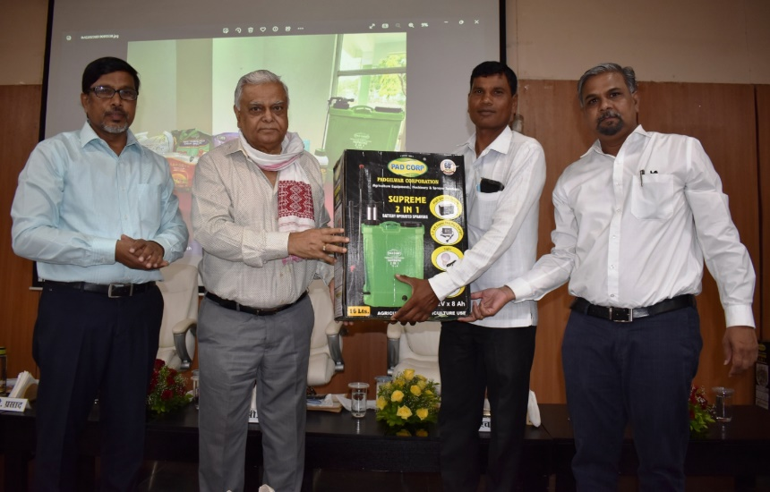
One day Workshop for Women Farmers "Training for capacity building and entrepreneurship development of farm women” at Durgada Ta. Deoli, Dist. Wardha

Input Distribution on the occasion of COTTON FARMERS WROKSHOP at ICAR-CICR, Nagpur

Farmer-Scientist interaction on the occasion of COTTON FARMERS WROKSHOP at ICAR-CICR, Nagpur

Input Distribution on the occasion of COTTON FARMERS WROKSHOP at ICAR-CICR, Nagpur

Input Distribution on the occasion of COTTON FARMERS WROKSHOP at ICAR-CICR, Nagpur

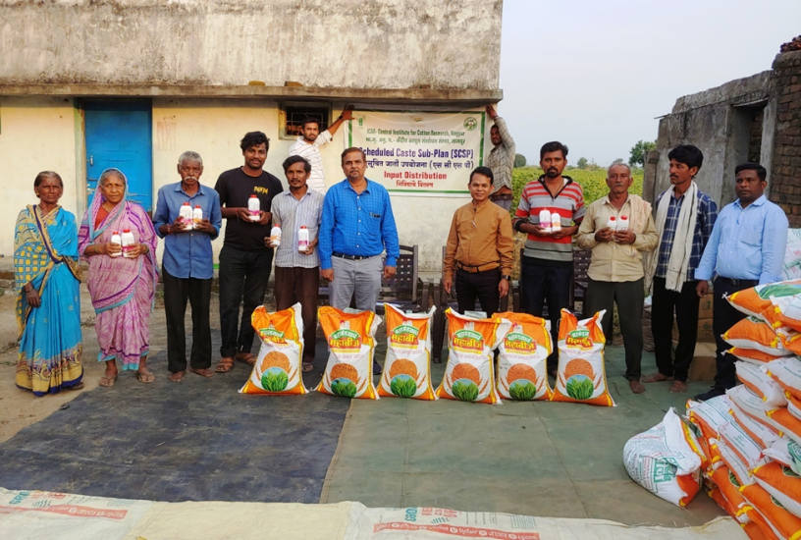
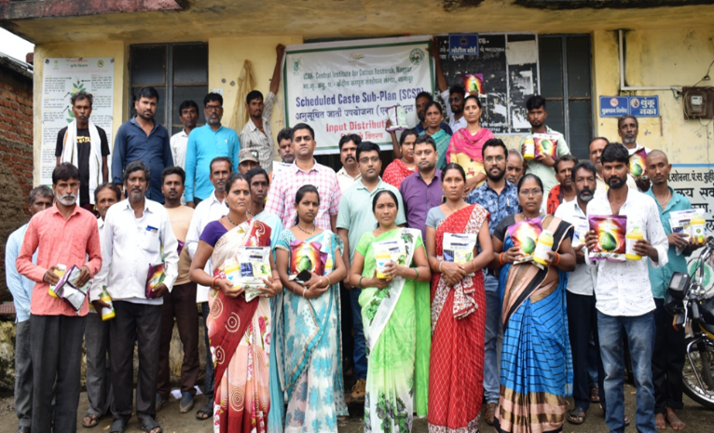
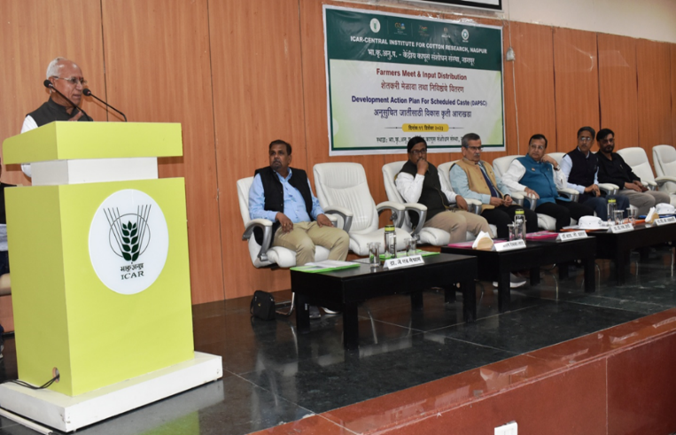
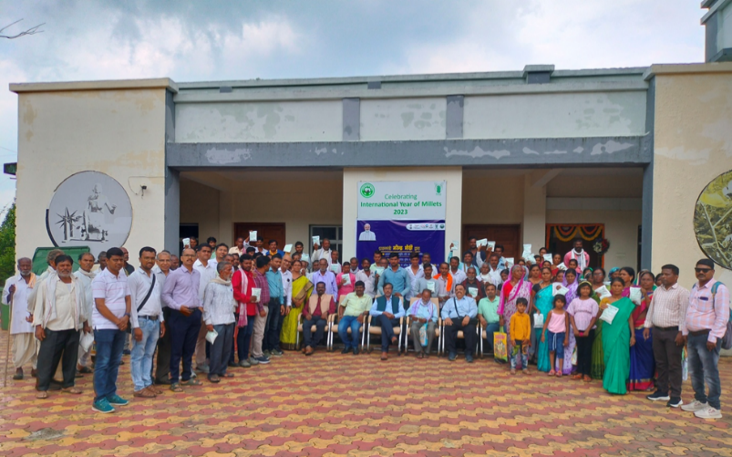
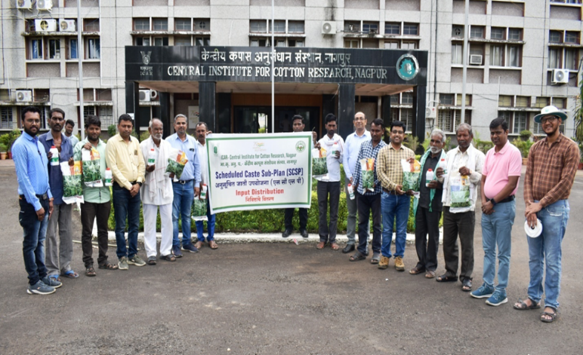
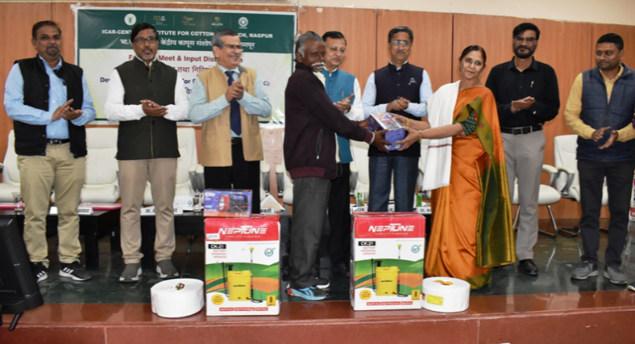
Wheat seed & Bio-Fertilizer kit distribution to SC farmers at Durgada, Ta. Deoli, Dist. Wardha.

Cotton seed & Herbicide distribution to SC farmers at Grampanchayat Khobna, Ta. Kuhi, Dist. Nagpur

Shri. Dadaji Lad addressing farmers, on the occasion of Kisan Mela At. ICAR-CICR, Nagpur

Farmers meet on the occasion of PM kisan Samman Sammelan at ICAR-CICR, Nagpur

Tur seed & Bio-Fertilizer distribution to SC farmers at ICAR-CICR, Nagpur

Input distribution on the occasion of Kisan Mela at. ICAR-CICR, Nagpur

