Annual Report of “Development Action Plan for Scheduled Caste (DAPSC) (formerly SCSP) 2024”

Overview of the Scheme:
The Development Action Plan for Scheduled Castes (DAPSC), previously known as the Scheduled Caste Sub Plan (SCSP), is a central government-sponsored initiative aimed at improving the livelihoods of Scheduled Caste (SC) communities, primarily through agricultural development and skill enhancement. Implemented by ICAR-CICR, Nagpur, the program sought to enhance productivity and income within SC households by addressing agribusiness needs and promoting the use of available resources.

Objective:
The main objectives of the scheme were:
- Increase Income Levels: Elevate the income of SC families through targeted income-generating schemes, skill development, and infrastructure improvement.
- Enhance Agricultural Productivity: Provide technological support and scientific guidance to increase productivity and improve agricultural practices.
- Capacity Building: Offer training and workshops to build skills and knowledge, empowering the SC community, especially women.

Program Implementation:
The DAPSC was implemented in five districts of Maharashtra with a high SC population (50% or more). These districts included:
- Nagpur
- Wardha
- Chandrapur
- Amaravati
- Yavatmal
Key implementation steps:
- Beneficiary Identification: Families were identified with the help of State Government Agencies.
- Program Planning & Execution: Planned at the institute level and executed through a committee formed for each adopted village.
- Targeted Poor SC Families: The scheme directly benefited the poorest families, providing them with agricultural inputs and technological support.

Key Activities and Interventions:
- Technological Interventions:
  - Dissemination of scientific knowledge and agricultural practices.
  - Introduction of new technologies and pest management solutions.
  - Regular interface meetings and timely solutions to farmers' issues.

- Skill Development:
  - Regular skill development programs and workshops on agricultural practices, business development, and entrepreneurship.
  - Exposure visits to improve farmers' understanding of best practices.
- Empowerment of Women Farmers:
  - Mobilization of women from SC families to form Self-Help Groups (SHGs).
  - SHGs received capacity-building training, entrepreneurship development, and technical assistance to generate sustainable, year-round income.
- Agricultural Support:
  - Farmers were trained in the scientific cultivation of cotton through a complete package of practices, including the use of high-quality seeds and integrated pest management.

Team Involved in the Implementation:
The program was executed by the following committee members:
- Nodal Officer:
  - Dr. J. H. Meshram, Principal Scientist (Plant Physiology)
- Members:
  - Dr. Ramkrishna G. I., Sr. Scientist (Agronomy)
  - Dr. S. P. Gawande, Sr. Scientist (Plant Pathology)
  - Dr. B. B. Fand, Sr. Scientist (Entomology)
  - Dr. N. S. Hiremani, Scientist (Plant Pathology)
  - Dr. U.V. Galkate, SMS (Veterinary Sciences), KVK
  - Shri. Sheopal H. Mandape, Sr. Technician
  - Shri. Akshay K. Kamble, Sr. Technician
  - SAO & FACO

Achievements:
- Improved Productivity & Income: Farmers' agricultural productivity improved, leading to increased incomes.
- Empowered Women: Women farmers gained independence and entrepreneurship skills through SHGs.
- Enhanced Agricultural Knowledge: Farmers were trained in modern cotton cultivation techniques, leading to better yields.
- Infrastructure Development: Improvements in sanitation, public premises cleanliness, and awareness of state agricultural schemes benefitted the local communities.

Conclusion:
The Development Action Plan for Scheduled Caste (DAPSC) in 2024 successfully enhanced the livelihoods of SC communities through targeted agricultural and capacity-building interventions. By empowering both men and women, the program brought about sustainable changes in farming practices and household incomes, making a significant impact in the rural areas of Maharashtra.

The details of various Training programme conducted under DAPSC during 2024

Sr.  No. | Name of programme | Venue and Date | Male benefi-ciary | Female benefi-ciary | Total No. of SC benefic-iaries | Programmes Details
1. | Farmers training on “Opportunities and Challenges in Livestock Production” | Veterinary College, Nagpur  16 January 2024. | 100 | 0 | 100 | Farmers from Khadki Ta. Narkhed, Hingna Ta. Saoner, Parsodi Ta. Parseoni, Wadvihara & Mendhepathar Ta. Katol, dist. Nagpur participated in training cum workshop on livestock production and management.
2. | Farmers training on  “Role of Livestock Production in Sustainable Agriculture" | ICAR-CICR, Nagpur  21 February 2024. | 98 | 8 | 106 | SC Farmers from Nagpur and Wardha District participated in Interface Farmers Meeting on “Livestock Production in Sustainable Agriculture "
3. | Farmers meet on the occasion of  “16th instalment of PM KISAN SAMMAN NIDHI” and Training on Integrated Cotton Management | ICAR-CICR, Nagpur  28 February 2024 | 67 | 4 | 71 | Online webcasting of Hon. Prime Minister Shri. Narendra Modi on the occasion of “16th instalment of PM KISAN SAMMAN NIDHI”
4. | Livelihood Enhancing Skill Development Training for Rural Women. | ICAR-CICR, Nagpur  06 March 2024. | 0 | 60 | 60 | One day training on Livelihood Enhancing Skill Development Training for Rural Women from Nagpur, Wardha and Yavatmal District.
5. | Cotton farmers Training cum workshop, on “HDPS & Closer Spacing cotton cultivation Technologies” | Malkapur & Gandhinagar Ta, Kalamb, Dist. Yavatmal.  14 June 2024. | 47 | 9 | 56 | One day Farmers training cum workshop on HDPS & Closer Spacing cotton cultivation Technologies.
6. | Cotton farmers Training on “Integrated Cotton Management” | ICAR- Central Institute for Cotton Research, Nagpur.  12 July 2024. | 124 | 15 | 139 | Conducted Workshop on Best Management Practices for Enhancing Cotton Productivity. Farmers from Nagpur, Amravati and Wardha participated in this program.
7. | "Training on PB Rope" | Naigaon Ta. Daryapur, Dist. Amravati  12 August 2024 | 19 | 6 | 25 | Farmers training on PBW Management and use of PB rope technologies.
8. | "Training on PB Rope" | Bhajipani Ta. Katol, Dist. Nagpur  13 August 2024 | 12 | 2 | 14 | Farmers training on PBW Management and use of PB rope technologies.
9. | "Training on PB Rope" | Malkapur, Ta. Kalamb, Dist. Yavatmal  13 August 2024 | 14 | 3 | 17 | Farmers training on PBW Management and use of PB rope technologies.
10. | Field Exposure Visit | PDKV, Akola  20th to 22nd September 2024 | 244 | 68 | 312 | Field Exposure Visit on the Occasion of Shivar Pheri at. PDKV, Akola. Conducted for SC Farmers from Nagpur, Amravati, Yavatmal and Wardha district
11. | Visit of Shri Giriraj Singh Ji, Hon’ble Union Minister of Textiles | ICAR-CICR, Nagpur.  25 September 2024. | 3 | 2 | 5 | Interaction with farmers and critical input distribution by the hands of Shri Giriraj Singh Ji, Hon’ble Union Minister of Textiles.
12. | Cotton growing farmers training cum Field Visit at Cotton growing area | Malkapur & Gandhinagar Ta. Kalamb, Dist. Yavatmala  16 October 2024 | 40 | 10 | 50 | One day framers training cum field day program.
13. | Farmers Training cum Demonstration of Cotton Stalk Shredder. | ICAR-CICR, Nagpur.  17 December 2024. | 30 | 0 | 30 | Farmers training cum live demonstration of Cotton Stalk Shredder and Drone at CICR cotton field. Total 30 farmers from Malkapur & Sherad Ta. Kalamb, Dist. Yavatmal participated in this programme.
14. | Water ATM Visit | Khadki Ta. Narkhed & Chikhali Maina Ta. Katol Dist Nagpur  19 December 2024. | 65 | 27 | 92 | Water ATM RO Plant Inspection and Inauguration programme organized by ICAR-CICR, Nagpur under DAPSC at Khadki Ta. Narkhed and Chikhali Maina, Ta. Katol, Dist. Nagpur.
15. | Krishi Mela cum Input Distribution Programme | ICAR- Central Institute for Cotton Research, Nagpur.  20 December 2024. | 41 | 3 | 44 | Krishi Mela cum Input Distribution Programme organized by ICAR-CICR, Nagpur under DAPSC dated on 20 Dec. 2024 at ICAR-CICR, Nagpur. Total 44 SC farmers from Chondi Bahadarpur and Sawalapur, Ta. Arvi, dist. Wardha actively participated in Krishi Mela. Critical inputs like Tarpaulin, Irrigation Tube(Lapeta Pipe) and Pesticide Protection Kit distributed to SC beneficiaries.
The details of Critical input distribution under the DAPSC schemes during 2024.

Sr. No. | Name of Item | Venue and Date | No of SC bene ficiaries | Male bene ficiary | Female bene ficiary | Input distributed/  skill imparted
1. | Milk Can | ICAR-CICR, Nagpur  21 February 2024 | 106 | 98 | 8 | Distribution of Milk Can to SC beneficiaries from Pipardol, Amboli, Welsakhara, Godhani, Wadegaon, Tirkhura, Dhurkheda, Ta. Umred, Chikhali Maina, Mendhepathar, Wadvihara, Ta. Katol Dist. Nagpur. & Salapur, Ta. Samudrapur, Dist. Wardha.
2. | Water Purifier | ICAR-CICR, Nagpur  21 February 2024 | 71 | 67 | 4 | Distribution of Water Purifier to SC beneficiaries from Sawarkhanda, Ta. Kuhi, Hingna, Ta. Saoner, Dist. Nagpur, Mangaon & Salapur Ta. Samudrapur, Dist. Wardha
3. | Sewing Machine | ICAR- Central Institute for Cotton Research, Nagpur.  06 March 2024. | 60 | 0 | 60 | Distribution of Sewing Machine to SC female beneficiaries from Mendhepathar, Wadvihara Ta. Katol, Parsodi, Ta. Parseoni, Sawarkhanda, Ta. Kuhi, Wadegaon, Ta. Umred Dist. Nagpur, Durgada, Ta. Deoli, Dist. Wardha, Gandhinagar, Sherad & Malkapur Ta. Kalamb, Dist. Yavatmal.
4. | Goat and Goat feed | Punyashlok Ahilyadevi Mendhi Va Sheli Vikas Prakshetra, Bondri, Taluka. Ramtek, Dist. Nagpur  19 March 2024 | 52 | 43 | 9 | Vaccinated Two female goats & 50 Kg Goat Feed distributed to each Beneficiary from Hingna, Ta. Saoner, Parsodi, Ta. Parseoni, Wadvihara, Ta. Katol, Khadki, Ta. Narkhed. Dist. Nagpur.
5. | Goat and Goat feed | Punyashlok Ahilyadevi Mendhi Va Sheli Vikas Prakshetra, Pohra Bandi, Taluka, Dist. Amravati  21 March 2024 | 41 | 32 | 9 | Vaccinated Two female goats & 50 Kg Goat Feed distributed to each Beneficiary from Husenpur, Palwadi, & Katsur Ta. Teosa. Dist. Amravati.
6. | Tur Seed and Bio-Fertilizer | Vadvihara,Mendhepathar, Chikhali Maina, Ta. Katol, Khadki Ta. Narkhed, Hingna Ta. Saoner, Parsodi, Ta. Parseoni, Husenpur, Sultanpur, Katsur, Ta. Tiosa, Dist. Amravati Mangaon, Salapur Ta. Samudrapur Dist. Wardha  Malkapur, Gandhinagar,  Sherad, Ta. Kalamb, Dist. Yavatmal  6 June to 14 June 2024 | 500 | 410 | 90 | Tur (PKV – TARA)  Seed having 2 kg packing (4 Kg to each) distributed for Cotton intercropping to Scheduled caste farmers in Kharif season.
7. | Cotton Seed & Herbicide | Malkapur & Gandhinagar Ta, Kalamb, Dist. Yavatmal.  14 June 2024. | 56 | 47 | 9 | Rasi RCH 929 BGII & Rasi RCH 971 BGII of Cotton variety distributed for HDPS & Closer spacing cultivation Technologies to Scheduled caste farmers from Malkapur & Gandhinagar Ta, Kalamb, Dist. Yavatmal.
8. | Crop Protection Kit | Vadvihara,Mendhepathar, Chikhali Maina, Ta. Katol, Khadki Ta. Narkhed, Borgaon, Ta. Kamptee, Wadegaon, Pipardol, Ta. Umred, Khobna, Bodkhipeth, Amti, Sawarkhanda, Ta. Kuhi Hingna, Khairi Panjabrao, Ta. Saoner, Parsodi, Ta. Parseoni, Dist. Nagpur Husenpur, Sultanpur, Katsur, Ta. Tiosa, Morshi Khurd, Ta. Warud, Pohra Purna, Ta. Bhatkuli, Dist. Amravati  Mangaon, Salapur Ta. Samudrapur Chondi Bahadarpur, Sawalapur, Ta. Arvi, Durgada, Ta. Deoli Dist. Wardha Malkapur, Gandhinagar, Sherad, Ta. Kalamb, Dist. Yavatmal.  06 June 2024 to 30 August 2024. | 871 | 734 | 137 | Crop Protection kit contain Fungicides, Insecticides and Nutrient Kit
9. | LED Torch | Vadvihara,Mendhepathar, Chikhali Maina, Ta. Katol, Khadki Ta. Narkhed, Borgaon, Ta. Kamptee, Wadegaon, Pipardol, Ta. Umred, Hingna, Ta. Saoner, Dist. Nagpur Husenpur, Sultanpur, Katsur, Ta. Teosa, Morshi Khurd, Ta. Warud, Pohra Purna, Ta. Bhatkuli, Dist. Amravati Chondi Bahadarpur, Sawalapur, Ta. Arvi, Dist. Wardha  06 June 2024 to 30 August 2024 . | 415 | 348 | 67 | LED Torch distributed to SC Farmers from DAPSC adopted villages of Wardha, Amravati and Nagpur districts.
10. | Pesticide Protection Kit | ICAR- Central Institute for Cotton Research, Nagpur  12 July 2024 | 64 | 59 | 5 | Pesticide Protection kit having Apron, Hand Gloves, Gumboot, Helmet, Eye protection Goggle, Mask distributed to SC farmers from Nagpur, Amravati and Wardha district.
11. | Pharomone Trap & PBW Lure | Naigaon Ta. Daryapur, Dist. Amravati Malkapur Ta. Kalamb, Dist. Yavatmal and Bhajipani, Ta. Katol, Dist. Nagpur  Date12 & 13 August 2024 | 42 | 33 | 9 | Pharomone Trap & PBW Lure distributed to SC Cotton Growing farmers from Nagpur, Yavatmal and Amravati district for Pink Bollworm management.
12. | Cremit PBW Tube | Naigaon Ta. Daryapur, Dist. Amravati Malkapur Ta. Kalamb, Dist. Yavatmal and Bhajipani, Ta. Katol, Dist. Nagpur  Date 12 & 13 August 2024 | 42 | 33 | 9 | Cremit PBW Tube distributed to SC Cotton Growing farmers from Nagpur, Yavatmal and Amravati district for Pink Bollworm management.
13. | Gram Seed (Chickpea) | ICAR- Central Institute for Cotton Research, Nagpur  24 & 25 October 2024 | 299 | 256 | 43 | Gram seed Distributed to Scheduled caste farmers for Rabi season. Gram Variety, Jaki-9218 having packing 30 Kg bag. (one bag to each farmer)
14. | Wheat Seed | ICAR-CICR, Nagpur.  24 & 25 October 2024 | 200 | 166 | 34 | Wheat seed Distributed to Scheduled caste farmers for Rabi season. Wheat variety ‘MACS-6222’ having packing 20 kg bag. (two bag to each farmer)
15. | Bicycle Distribution | ICAR- Central Institute for Cotton Research, Nagpur.  05 December 2024. | 115 | 39 | 76 | 39 Men & 76 Woman bicycle distributed to SC student from DAPSC adopted villages of Wardha, Yavatmal and Nagpur districts.
16. | Student Kit | ICAR- Central Institute for Cotton Research, Nagpur.  05 December 2024. | 99 | 34 | 65 | Student kit having School bag, Water bottle, Compos box, Notebooks etc. distributed to SC student from DAPSC adopted villages of Wardha, Yavatmal and Nagpur districts
17. | Mobile Cotton Stalk Shredder | ICAR- Central Institute for Cotton Research, Nagpur.  17 December 2024. | 48 | 41 | 7 | 2 Mobile Cotton Stalk Shredder distributed to Farmers group  1. Krushi Utkarsh shetkari Sendriya Kad-Dhanya Uttpadak Gat, Malkapur, Ta. Kalamb and  2. Baliraja Shetkari Sendriya Dhanya Uttpadak Gat, Sherad Ta. Kalamb, Dist. Yavatmal.
18. | Tarpaulin | ICAR- Central Institute for Cotton Research, Nagpur.  20 December 2024. | 44 | 41 | 3 | Tarpaulin distributed to SC farmers from Wardha District
19. | Irrigation Tube (Lapeta Pipe) | ICAR- Central Institute for Cotton Research, Nagpur.  20 December 2024. | 44 | 41 | 3 | Irrigation Tube (Lapeta Pipe) distributed to SC farmers from Wardha District
20. | RO Water ATM unit | Khadki, Ta. Narkhed; Chikhali Maina, Ta. Katol; Khobna & Amti, Ta. Kuhi, Nagpur district | 170 | 132 | 38 | Four RO Water ATM machine installed to provide clean, and safe drinking water facility to rural villages- Khadki Ta. Narkhed, Chikhali Maina Ta. Katol, Khobna & Amti, Ta. Kuhi, of Nagpur district.
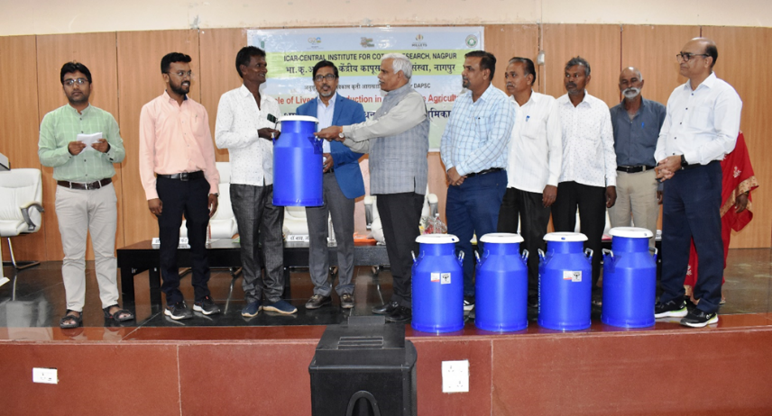
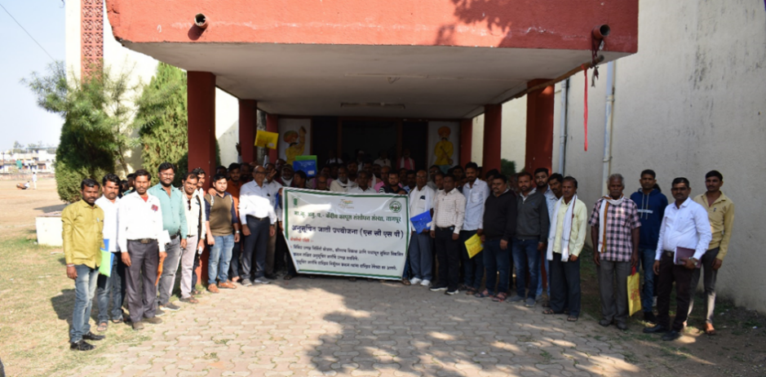
Farmers training on “Opportunities and Challenges in Livestock Production” at Veterinary College, Nagpur on 16 January 2024
Input Distribution on the occasion of Farmers training on “Role of Livestock Production in Sustainable Agriculture" at ICAR-CICR, Nagpur on 21 February 2024

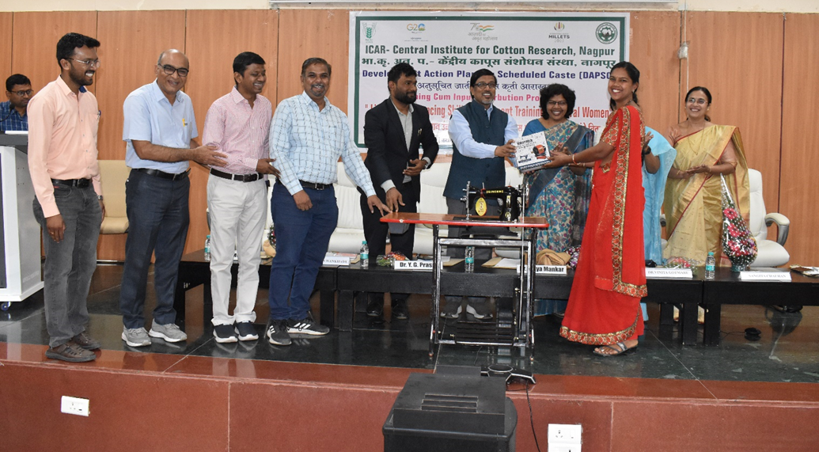
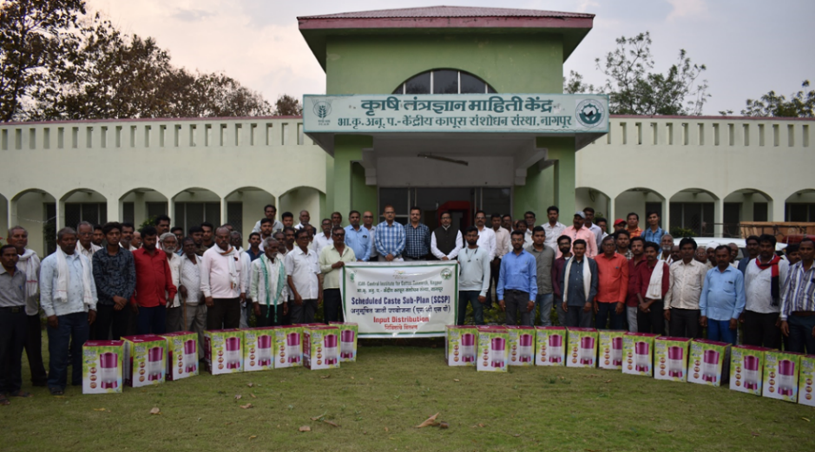
Livelihood Enhancing Skill Development Training for Rural Women & Sewing Machine Distribution at ICAR-CICR, Nagpur on 6 March 2024
Input Distribution on the occasion of 16th installment of PM KISAN SAMMAN NIDHI at ICAR-CICR, Nagpur on 28 February 2024

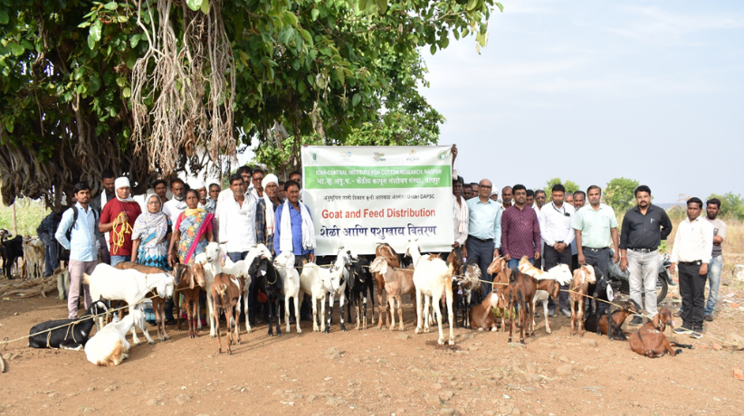
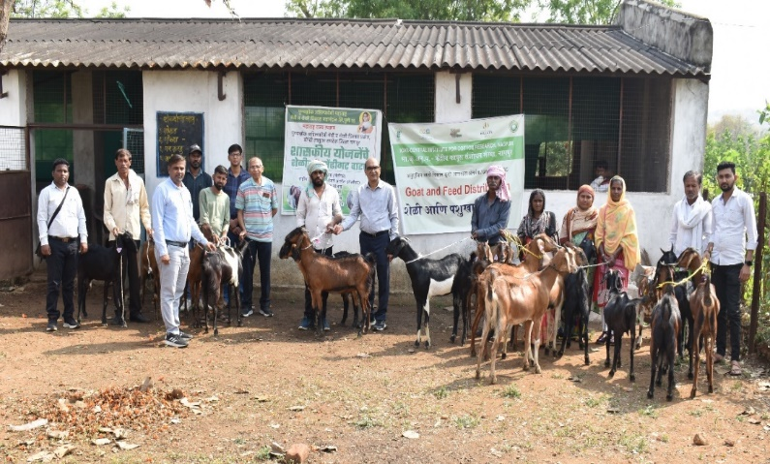
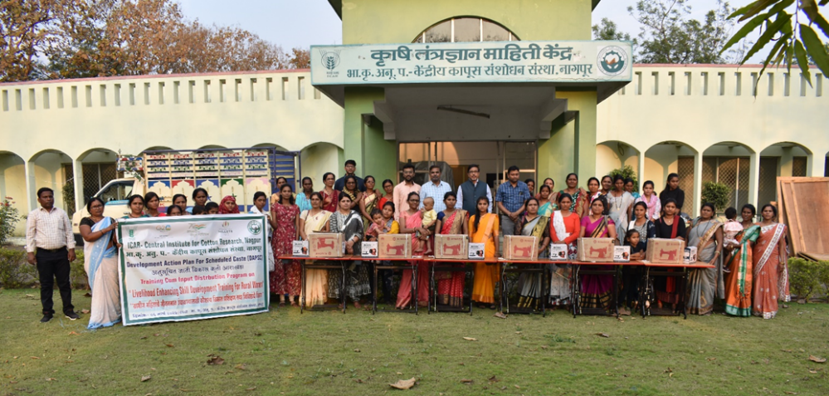
Goat distribution at Ahilyadevi Mendhi Va Sheli Vikas Prakshetra Pohara Bandi Ta. District Amravati on 21 March 2024

Livelihood Enhancing Skill Development Training for Rural Women & Sewing Machine Distribution at ICAR-CICR, Nagpur on 6 March 2024

Goat distribution at Ahilyadevi Mendhi Va Sheli Vikas Prakshetra Bondari, Ta. Ramtek District Nagpur on 19 March 2024

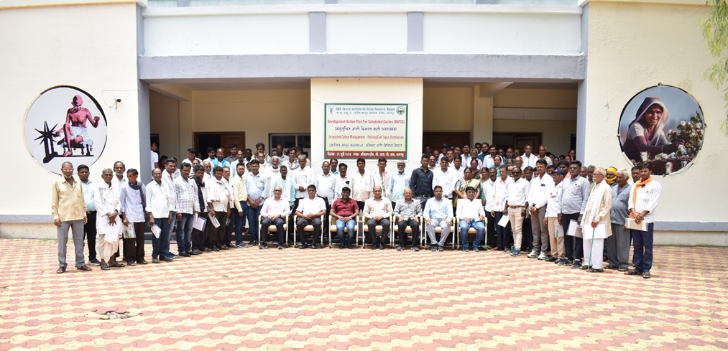
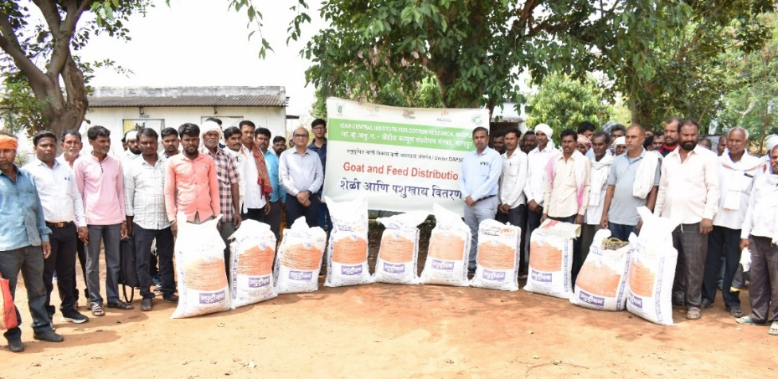
Cotton farmers Training on “Integrated Cotton Management” at ICAR-CICR, Nagpur on 12 July 2024
Goat feed distribution at Ahilyadevi Mendhi Va Sheli Vikas Prakshetra Bondari, District Nagpur on 19 March 2024

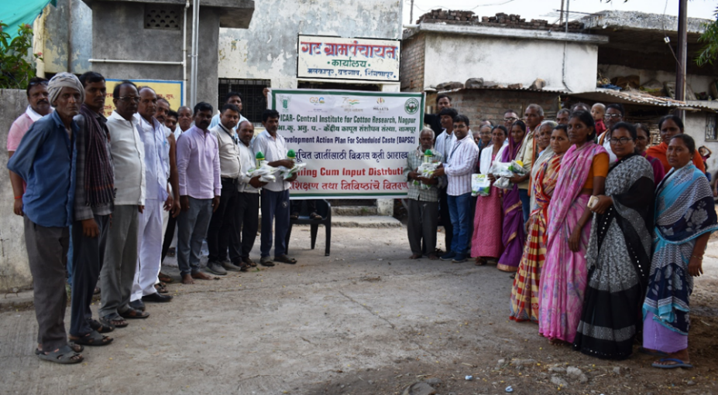
Cotton Seed & Bio-Fertilizers Distribution at Malkapur, Ta. Kalamb, Dist. Yavatmal on 14 June 2024

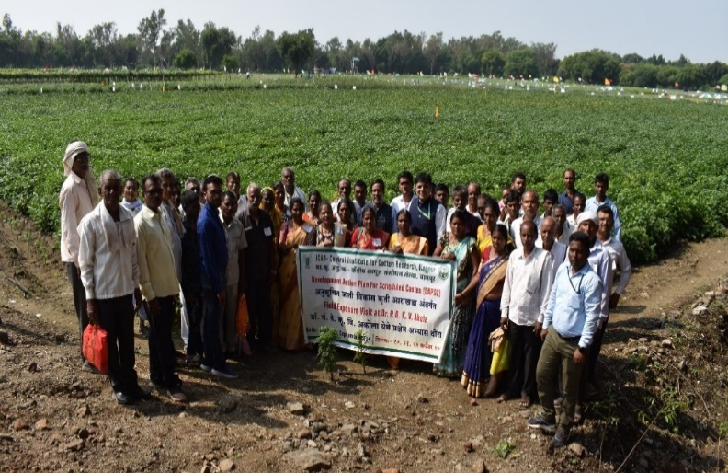
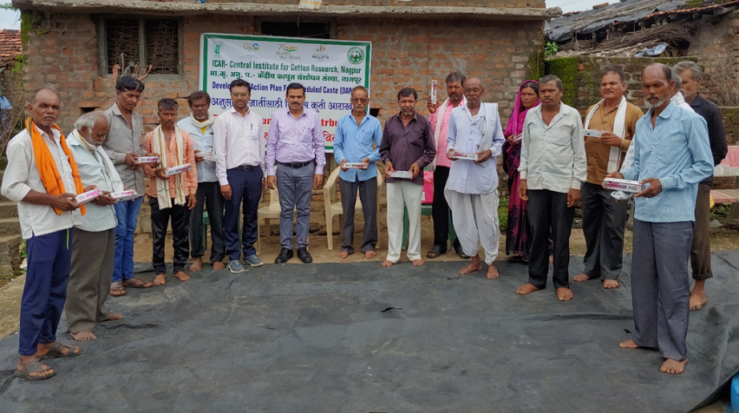
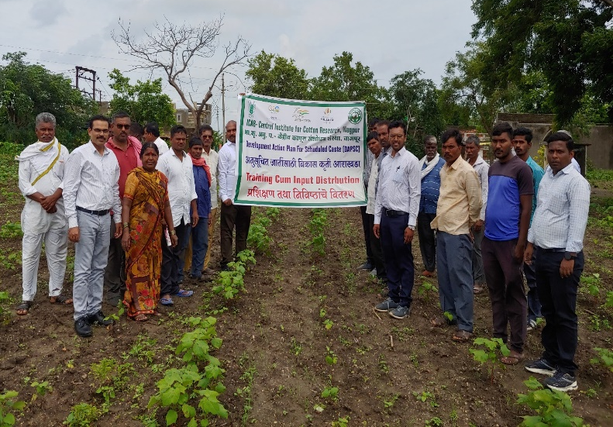
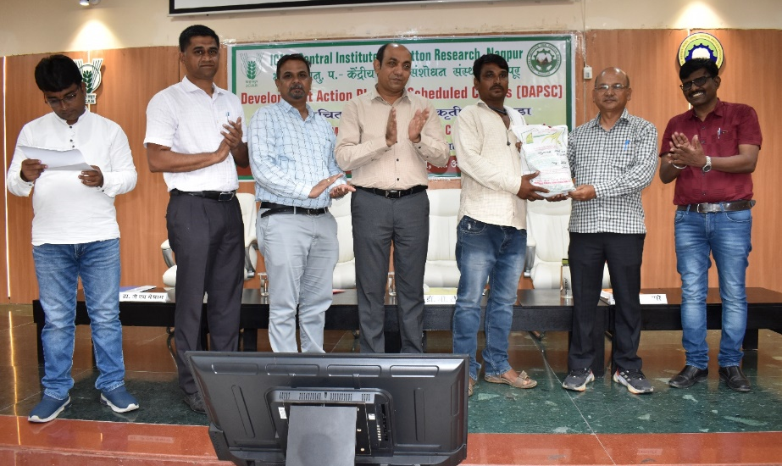
Field Exposure Visit on the occasion of Shivar Pheri at PDKV, Akola on 22 September 2024

Training on PB Rope and Input Distribution at Bhajipani Ta. Katol, Dist. Nagpur 13 August 2024
Field Exposure Visit on the occasion of Shivar Pheri at PDKV, Akola on 20 September 2024

Training on PB Rope and field visit at Naigaon, Ta. Daryapur, Dist. Amravati on 12 August 2024

Input Distribution on the occasion of Cotton Farmers Training on “Integrated Cotton Management” at ICAR-CICR, Nagpur on 12 July 2024

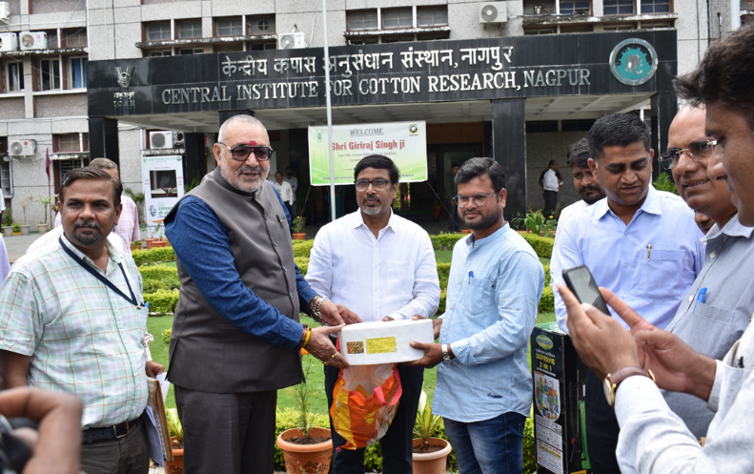
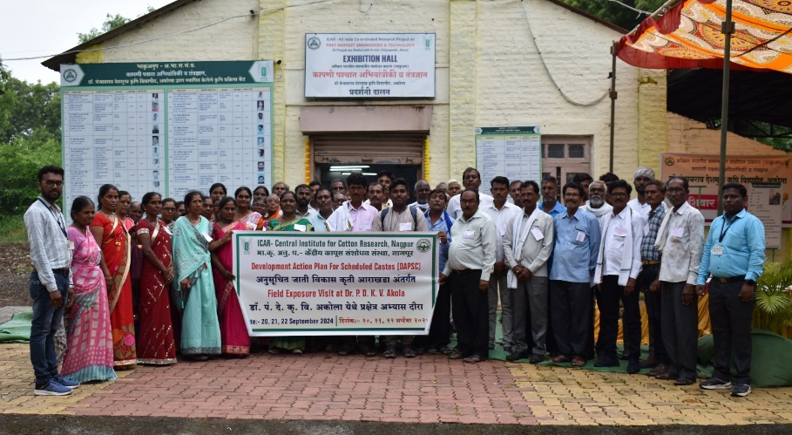
Shri Giriraj Singh Ji, Hon’ble Union Minister of Textiles Visit at ICAR-CICR, Nagpur on 25 September 2024

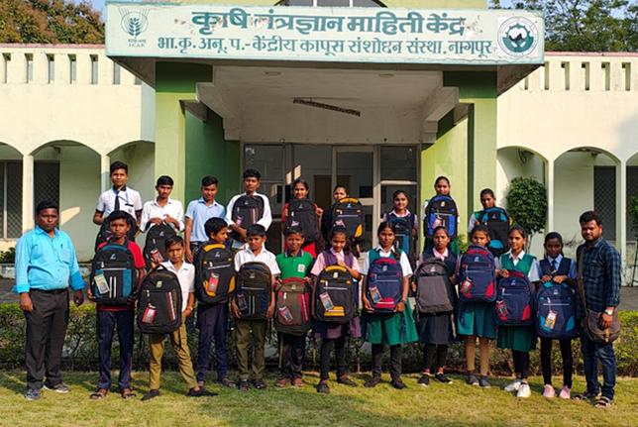
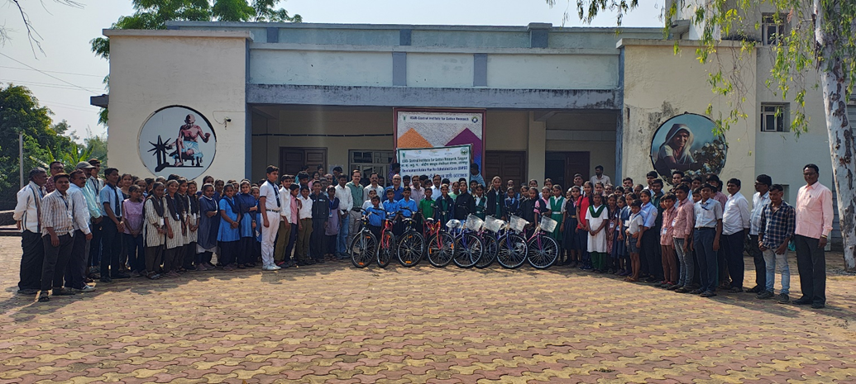
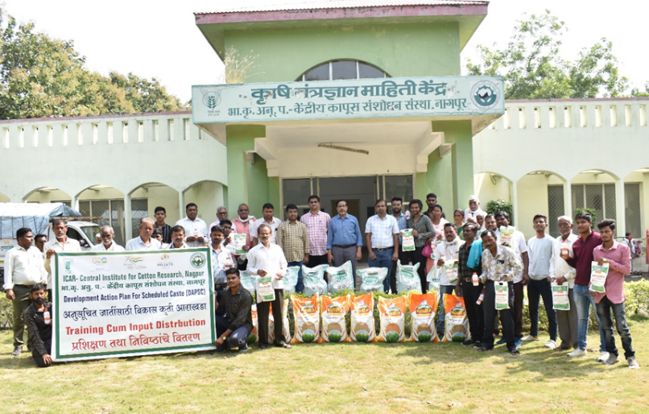
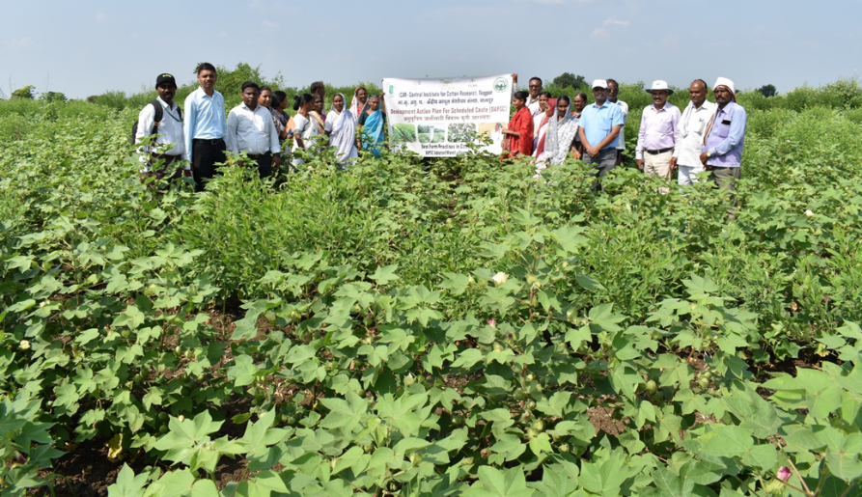
Student kit distribution to SC students at ICAR-CICR, Nagpur on 5 December 2024

Gram Seed, Wheat seed & Bio-Fertilizer kit distribution at ICAR-CICR, Nagpur on 24 December 2024

Cotton field visit at Malkapur, Ta. Kalamb, Dist. Yavatmal on 16 October 2024

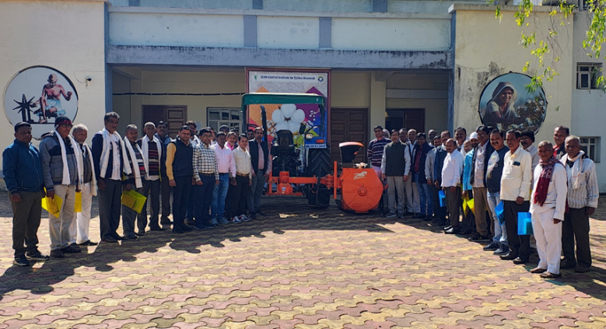
Mobile Cotton Shredder Demonstration at ICAR-CICR, Nagpur on 17 December 2024

Mobile Cotton Shredder Distribution at ICAR-CICR, Nagpur on 17 December 2024

Bicycle Distribution to SC students at ICAR-CICR, Nagpur on 5 December 2024

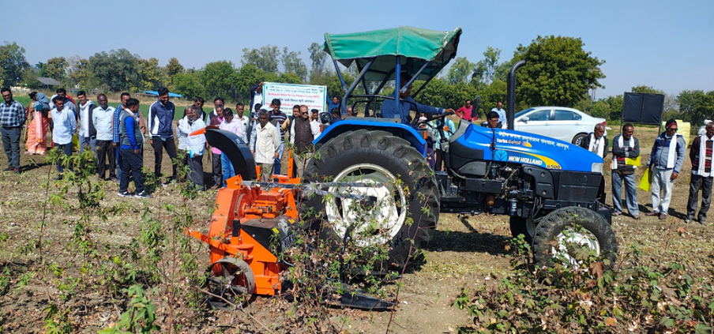

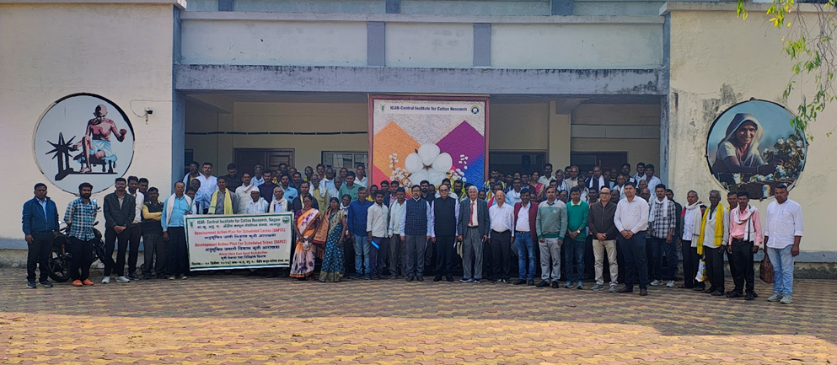
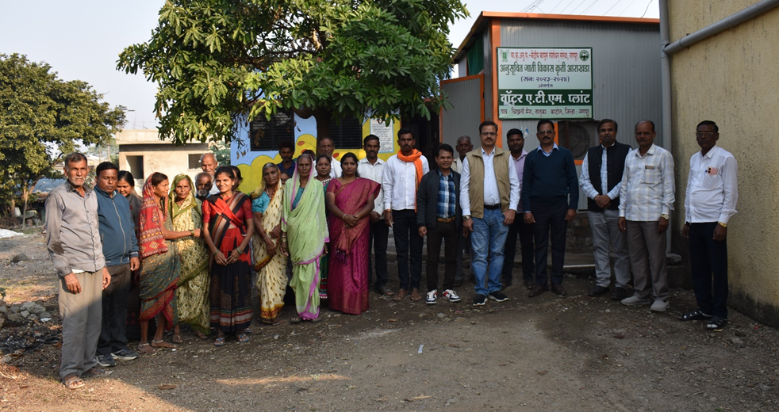
Krishi Mela cum Input Distribution Programme organized at ICAR-CICR, Nagpur on 20 December 2024

Water ATM RO Plant Inspection and Inauguration programme at Chikhali Maina, Ta. Katol, Dist. Nagpur on 19 December 2024
DAPSC activities at ICAR-CICR, Coimbatore

“Leveraging inproved cotton technologies and sustainable interventions for marginal SC Livelihoods/ SC farmers empowerment in Prambalur District on Tamil Nadu”

Beneficiaries identified: to address the issues, fifty farmers were identified from A. Kudikadu, Neikuppai and Keelaperambalur villages which comes under Veppanthattai and Veppur block of Perambalur district and the necessary inputs were supplied.

Details of input distributed to the beneficiaries: Seed wooden scale, NSKE 1L+ Pseudomons 1 Kg + Ullala 60 g +Emamectin Benzoate 100g + Cabrio top 300g + Planifix 100ml, + All19 – 4kg + PN-4kg + Westa boran -2kg + MAP – 2kg +lmidacloprid 17.8% SL 250ml, Lambdacyhalothrin 5% EC 500ml, Profenofos 50% EC 500ml, Carbendazim 50% WP 1 kg, Dryland weeder, Waterproof Tarpaulin Sheet, Sprayer, Back pack bag, File, Pen and Note pad.

Aim: This program is aimed to enhance the productivity of cotton from the SC farmers of selected village by providing key competencies to the farmers and through technology intervention.

Objectives:
- To identify the critical needs of SC farmers through baseline surveys in the study areas
- To carry out the need-based Capacity augmentation programmes, like training on selected technologies- closer spacing, drip fertigation, and other crop protection technologies for enhancing the yield and income.
- To provide critical input to identified & needy beneficiaries, enhance the cotton production and increase the income.
- To obtain feedback form the selected SC beneficiaries for project appraisal and further Scalability

Outcome:
- After completing this programmes, all the beneficiaries were able to Understand the best varietal selection, the Importance of soil health in better crop yield
- Importance of closer spacing in rainfed cultivation of cotton
- Role of organic and bio-intensive pest management practices in sustainable cotton production
- Reduce cost of cultivation: Preparation and use of organic inputs will reduce the cost of cultivation and increase the yield, and the quality of the crop is improved. Further, all the beneficiaries acknowledged this project by witnessing a higher yield than that of the previous years.

The details of various Training programme conducted under the DAPSC during 2024.

Sr.  No. | Name of programme | Venue and Date | Male Beneficiary | Female Beneficiary | No of SC beneficiaries | Programmes Details
1. | "Leveraging improved cotton technologies and sustainable interventions for marginal SC Livelihoods / SC farmers' | KVK, Perambalur,  08 August 2024 | 29 | 21 | 50 | Farmers training cum input distribution
2. | Farmers training on Cotton HDPS field Demonstration cum input distribution event for SC farmers engaged in cotton cultivation | Panchayat Union Office in Valikandapuram, Perambalur district  13 September 2024 at the | 29 | 21 | 50 | HDPS field Demonstration cum input distribution event for SC farmers engaged in cotton cultivation
3. | Cotton HDPS field Demonstration cum input distribution event for SC farmers engaged in cotton cultivation | Kudikadu, Neykuppai, and Keezhaperambalur villages of the Perambalur district  24-25 October 2024 | 21 | 21 | 50 | Farmers awareness programme on cotton pest management cum input distribution

Publication:
- Shankarganesh, K., Ramesash, K., Sampathkumar, A., Raja, R., Manicckam, S., Prakesh, A.H and Pradad, Y.G. 2023. Cotton Insects Pests and their Management (Tamil Bulletin) P.1-24
- Sampathkumar, A., Shankarganesh, K., Ramresh, K., Raja, R., Maniccham, S., Prakash, A.H and Prasad, Y.G. 2023. Disesses of cotton and their integrated Diseasis management (Tamil Folder) P.1-6
- Raja, R., Shankarganesh, K., Ramesh, K., Sampathkumar, A., Manicckam, S., Prakhash, A.H and Prasad, Y.G. 2023. Fertilizer management of ELS cotton (Tamil Folder). P. 1-4
- Shankarganesh, k., Ramesh, K., Sampathkumar, A., Raja, R. and Manickam, S. 2025. A training on Cultivation of cotton to Perambalur district farmers, Thinamani (Local Daily) Shankarganesh, K., Ramesh, K., Sampathkumar, A., Raja, R., Manicckam, S. and Prakhash, A. H. 2025. A training on Cultivation of cotton and inputs distribution to Perambalur district farmers, Thinamani (Local Daily).

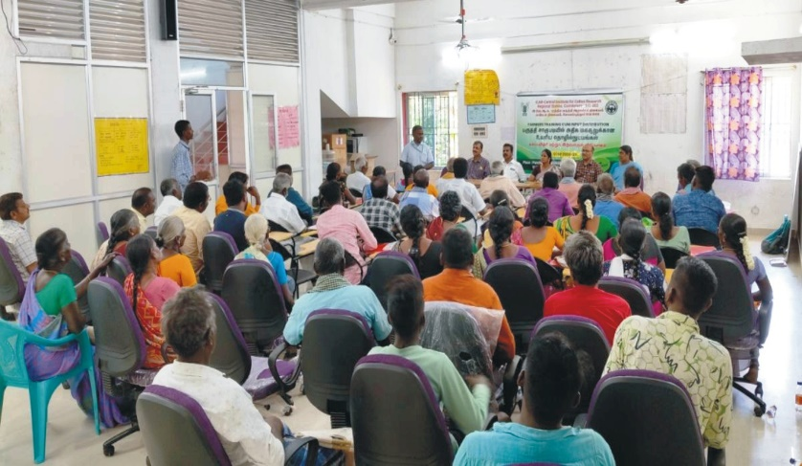
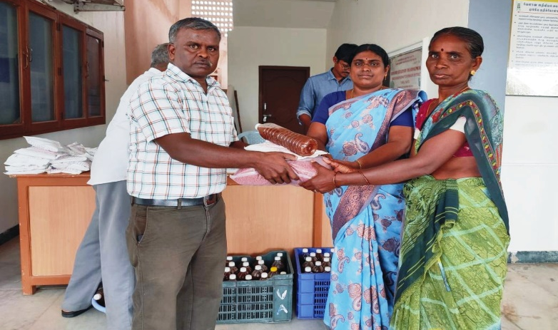
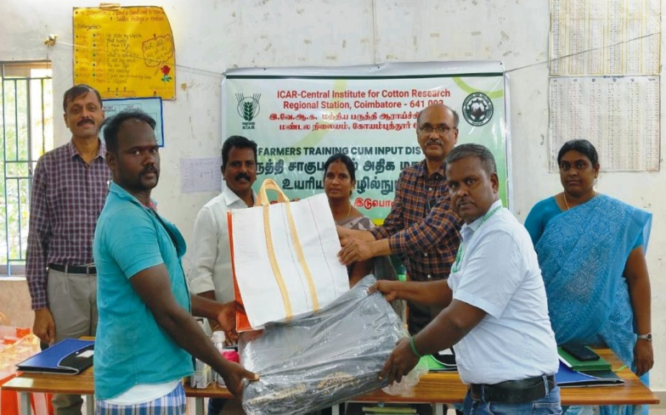
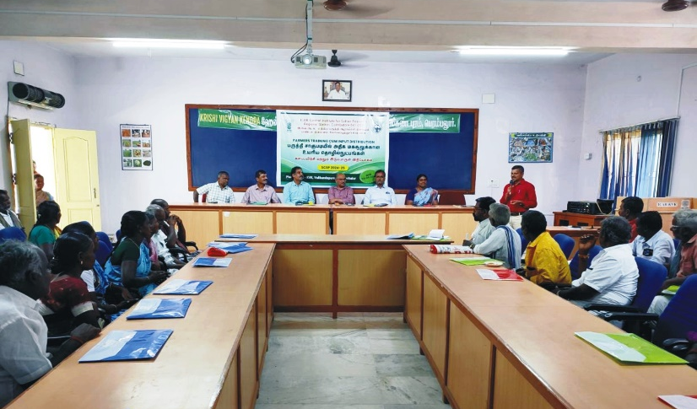
DAPSC training programme on 08.08.2024 at RS CICR, Coimbatore
Inputs distribution to SC farmers at RS CICR, Coimbatore

DAPSC training programme and Inputs distribution to the farmers on 13.09.2024 at RS CICR, Coimbatore

DAPSC training programme and Inputs distribution to the farmers on 13.09.2024

